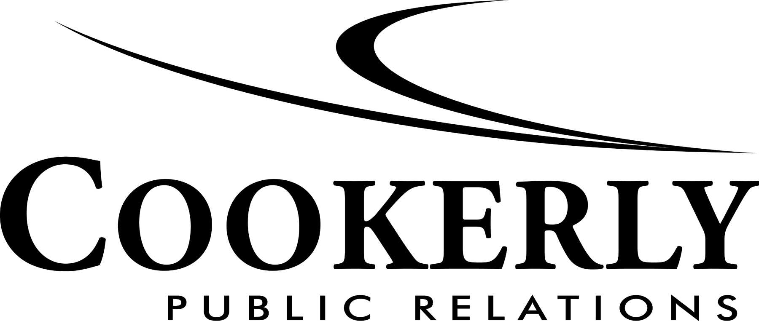

INTERNSHIP INFORMATION
Since 1991, Cookerly Public Relations has grown into one of Atlanta's leading mid-sized agencies representing a client roster more typical of national firms. The Atlanta Business Chronicle consistently ranks Cookerly as one of “Atlanta’s 20 Largest PR Firms,” and we have maintained that status for more than 23 years by offering a variety of client services across all major business categories including, but not limited to:

- Business-to-business
- Consumer
- Energy
- Environment
- Finance
- Healthcare
- Issue Management
- Law
- Non-profit
- Public Affairs
- Real Estate
- Technology
That being said, a company is more than its rankings. Cookerly was built on the idea that you’re only as good as the number of happy clients you have, and we place great focus on people and building solid relationships. Because of this, we have built a client base that includes Merrill Lynch, SunTrust, Cancer Treatment Centers of America, Anisa International and GEMA’s Ready Georgia campaign.
Unlike larger corporations where interns usually work on one or two client accounts, our interns are ingrained in most aspects of our agency. They are exposed to multiple service areas and gain a basic knowledge of public relations across a variety of industries. Students are often asked, “What do you want to do in PR?” We give them wide experience so they are better able to answer that question, both for others and more importantly, themselves.
Attaining PR experience involves much more than making coffee, so we give our interns hands–on experience ranging from writing to pitching media to account team meetings with senior management.
Internships are offered during fall, spring and summer. To apply to join the Cookerly team, please e-mail your application to Cindy Brannon at contactus@cookerly.com.
Your application should include the following:
- Cover letter
- Resume
- 1-2 writing samples (articles, press releases, fact sheets or class assignments)
- Application

*Send application packet in one attached Word document or PDF file. Multiple files will not be accepted.

Monarch Tower • 3424 Peachtree Road NE • Atlanta, GA • (P) 404.816.2037 • (F) 404.816.3037
Website • Blog • Facebook • Twitter • LinkedIn

Cookerly Public Relations Internship Application

Potential Start Date: ___________________
Name: __________________________________________________________________________
Months you are available to participate in the program: ____________________________________
If not available full time, days/hours you are available: ____________________________________

Please answer the following:

- What interests you about public relations?

- What interested you in our internship program?

- What do you feel you could contribute to an internship position?

- Please describe one of your greatest achievements.

- Please describe previous work/internship experiences and the most important thing you learned.

- Please describe your involvement in volunteer or campus activities.

For the following traits or statements, mark the number you feel best describes you.

Right brain/Left brain:
Very Creative 1 2 3 4 5 6 7 8 9 10 Very analytical

Organization style:
I’m always organized. 1 2 3 4 5 6 7 8 9 10 I’ve learned to love chaos.

Work style:
Team-oriented 1 2 3 4 5 6 7 8 9 10 Prefer to work alone

I can juggle multiple tasks at once.
Strongly disagree 1 2 3 4 5 Strongly agree

I prioritize projects and meet my deadlines.
Strongly agree 1 2 3 4 5 Strongly disagree

Please rank practice areas of interest 1 (of most interest) to 9 (of least interest)

______ Financial (e.g. Merrill Lynch)
______ “Green”/Environmental (e.g. Livable Buckhead)
______ Legal (e.g. Hunton & Williams)
______ Government (e.g. Ready Georgia)
______ Non-profit (e.g. Arthritis Foundation)
______ Retail/Consumer (e.g. Anisa International)
______ Technology (e.g. Intelligent Hospital Systems)
______ Education (e.g. University of West Georgia)
______ Issue Management
______ Healthcare (e.g. Cancer Treatment Centers of America)

Mark all types of client work you’d enjoy.

______ Newsletter writing ______ Strategy/planning
______ Media pitching ______ Social media
______ Tracking media coverage ______ Internal communications
______ Sales/new business research ______ Event planning
______ Researching/drafting press releases

Please list the following as they apply:

- Computer skills:

- Foreign languages:

- Awards:

- Membership in organizations:

ESSAY:
Write a short essay on ONE of the following three topics.
    - Describe your most challenging situation. How did you handle it?

    - Describe why PR is important to the success of businesses and organizations.

    - What do you think are the most important skills for a PR practitioner?

Contact:
Cindy Brannon, Office Manager
Cookerly Public Relations
3424 Peachtree Road NE
Suite 500
Atlanta, GA 30326
(404) 816-2037
contactus@cookerly.com

